Values Compass Reflection Worksheet
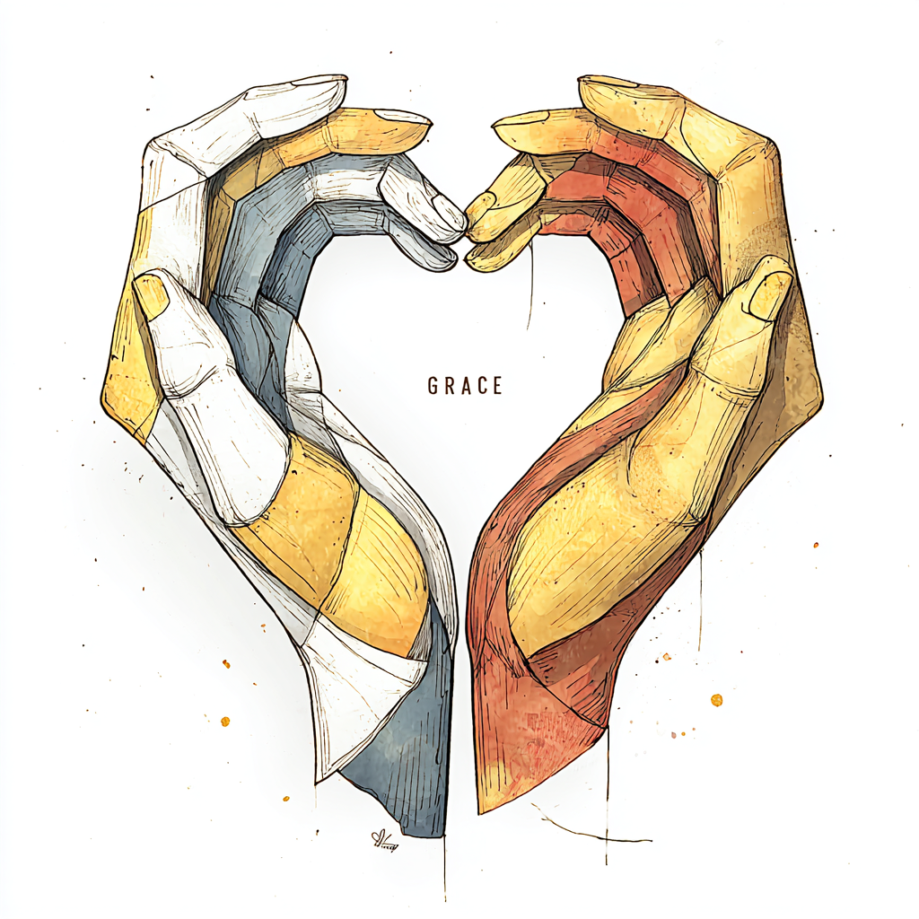

Part 1: Initial Reflection
- When you think of grace, what do you think of first?

- There are many forms of grace, physical grace, spiritual grace, grace for self, and others. What stands out to you as the easiest to do? What about the hardest?

- How have you seen grace used in a positive way? Do you remember a time you showed someone grace, or were shown grace? How did it feel?

Activities to consider:

Spiritual Grace
This is about recognizing undeserved favor and practicing forgiveness.
- Practice a "one-minute meditation." Set a timer for 60 seconds. Close your eyes and focus on your breathing. Think about one thing you have in your life that you didn't earn or deserve—it could be a beautiful sunset, a kind word from a stranger, or simply the ability to breathe easily. This helps you recognize the idea of unmerited gifts.
- Write down a forgiveness note (that you don't have to send). Think of a small grievance you have against someone. Write down a few sentences forgiving them for it. The goal isn't to confront them, but to release the feeling of resentment within yourself, which is a form of grace.

Social Grace
This is about poised, compassionate, and elegant interactions with others.
- Practice active listening. In your next conversation, make a conscious effort to just listen to the other person without interrupting. Notice their tone, their body language, and the full meaning of their words. It shows respect and a quiet, graceful presence.
- Offer a genuine compliment. Find something specific you genuinely appreciate about someone—a co-worker, a friend, or a cashier—and tell them. It could be "That's a really sharp point you made in the meeting," or "I love the color of your jacket." This small act of kindness is a display of social grace.

Personal Grace
This is about self-compassion, acceptance of imperfections, and inner peace.
- A "graceful reset" exercise. The next time you make a small mistake—spill a little coffee, send a typo in an email, or forget something—instead of getting frustrated, simply acknowledge it without judgment. Say to yourself, "Oops, that happened," and move on. This is a gentle way to practice self-forgiveness.
- Journal a "kindness list." At the end of the day, write down three things you did that were kind to yourself. This could be something as simple as drinking a glass of water when you were thirsty, taking a short walk, or allowing yourself to rest. It builds a habit of recognizing your own self-compassion.

Physical Grace
This is about effortless and smooth movement.
- Mindful walking. Instead of rushing, pay attention to the act of walking. Notice the roll of your foot from heel to toe, the swing of your arms, and how your posture feels. This can be done on your way to your car or even just around the room. The goal is to feel the elegance in your own movements.
- The "reach and relax" stretch. While sitting at a desk or standing in line, slowly reach your arms overhead. Imagine stretching your body as if you're pulling a string from the ceiling. Then, gently and slowly lower your arms. This simple, fluid motion helps you feel connected to the graceful movement of your body.

Other Grace
- Make a playlist. This can be songs that remind you of grace, that discuss grace, or sound graceful.
- Consider using Suno to make your own song.

Part 2: Experience
- Self-Care Activity 1: describe the activity and why it was chosen.

- What was the experience like? How did it feel to engage with this activity?

- My Self-Care Activity 2: describe the activity and why it was chosen.

- What was the experience like? How did it feel to engage with this activity?

- My Self-Care Activity 3: describe the activity and why it was chosen.

- What was the experience like? How did it feel to engage with this activity?

Part 3: Final Reflections
- Did exploring this value surprise you? Why or why not? What were the feelings associated with exploring this value? Were there Jewels (positives)? What about Ashes (negatives)?

- How do I feel about this value now? Has my understanding of it changed? Will I continue any of these activities, or similar ones? Why or why not?

