Values Compass Reflection Worksheet
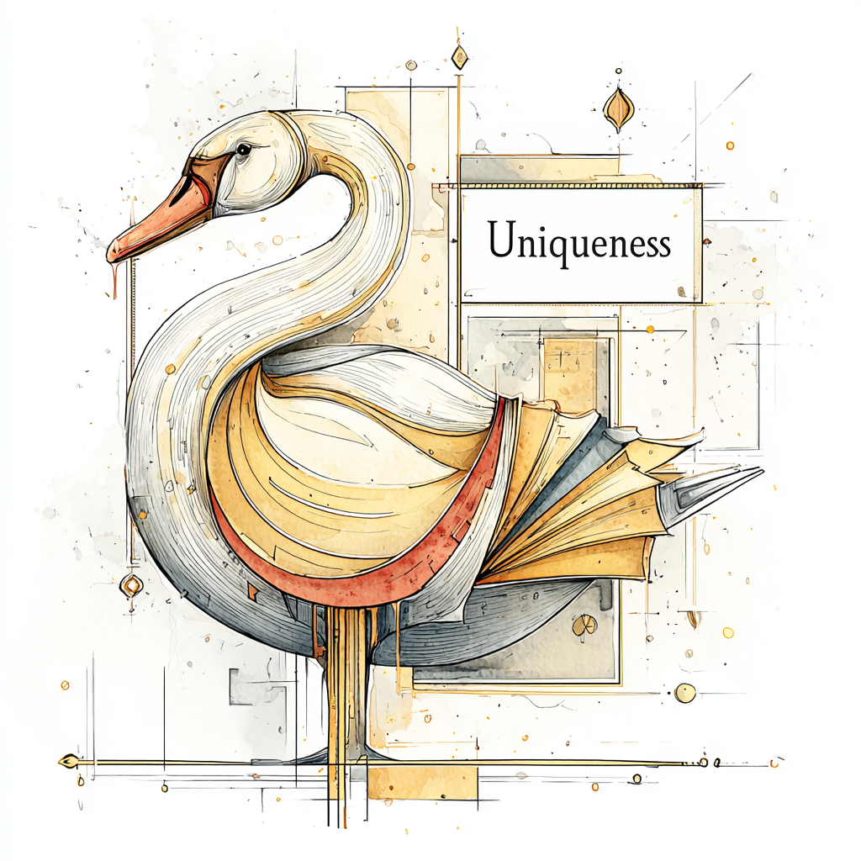

Part 1: Initial Reflection
- When you think of grace, what do you think of first?

- When you think of uniqueness, who, or what do you think of first? What might make it easier or harder for you to connect with this? What stands out to you as the easiest to do? What about the hardest?

- How have you seen uniqueness used in a positive way? Do you remember a time you felt unique? How did it feel?

Activities to consider:

Self-Reflection and Personal Exploration
- Create a "Unique Me" journal: Dedicate a journal to exploring what makes you unique. Write about your personal experiences, unusual hobbies, quirky habits, and unique perspectives. Reflect on times you felt different or went against the grain.
- Take a personal inventory: List your strengths, weaknesses, passions, and fears. Identify how these traits combine to create your unique identity. Consider how your background, culture, and life experiences have shaped you.
- Write your personal manifesto: Draft a document that outlines your core beliefs, principles, and values. This exercise forces you to articulate what you stand for and what you believe makes you, you.

Creative Expression
- Pursue an unconventional hobby: Try something you've never done before, especially if it's outside your comfort zone. This could be anything from learning to play the theremin to taking a glass-blowing class. The act of learning a unique skill can highlight your personal interests and abilities.
- Create something from scratch: Don't just follow a tutorial. Try to create a piece of art, music, or writing that is entirely your own. For example, write a short story with a character who shares one of your unique traits, or compose a simple melody that reflects your mood.
- Develop a unique personal style: Experiment with your clothing, home decor, or digital presence to reflect your individuality. Don't worry about what's trendy; focus on what feels authentic to you.

Appreciating Others' Uniqueness
- Conduct an "uniqueness interview": Ask a close friend, family member, or colleague to describe what they believe makes them unique. Listen without judgment and find a way to affirm their individuality. This can help you see the value in others' uniqueness and, by extension, your own.
- Celebrate differences: Intentionally seek out and learn about people from different cultures, backgrounds, or walks of life. The more you appreciate the uniqueness of others, the more you can appreciate your own.
- Read diverse biographies: Read about the lives of individuals who were known for being unconventional, such as artists, inventors, or activists. Consider how their unique qualities contributed to their success or impact on the world. This can inspire you to embrace your own distinctiveness

Part 2: Experience
- Self-Care Activity 1: describe the activity and why it was chosen.

- What was the experience like? How did it feel to engage with this activity?

- My Self-Care Activity 2: describe the activity and why it was chosen.

- What was the experience like? How did it feel to engage with this activity?

- My Self-Care Activity 3: describe the activity and why it was chosen.

- What was the experience like? How did it feel to engage with this activity?

Part 3: Final Reflections
- Did exploring this value surprise you? Why or why not? What were the feelings associated with exploring this value? Were there Jewels (positives)? What about Ashes (negatives)?

- How do I feel about this value now? Has my understanding of it changed? Will I continue any of these activities, or similar ones? Why or why not?

